Task 1
Automated test cases
Test Scenario
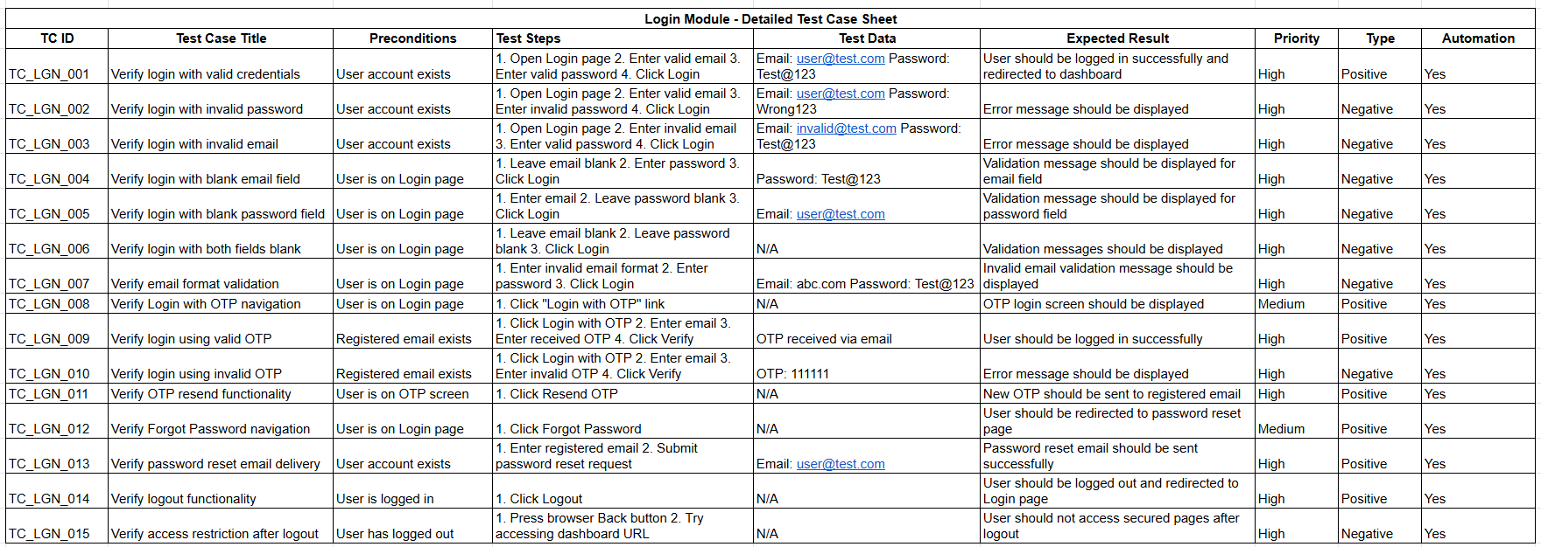
Home Page
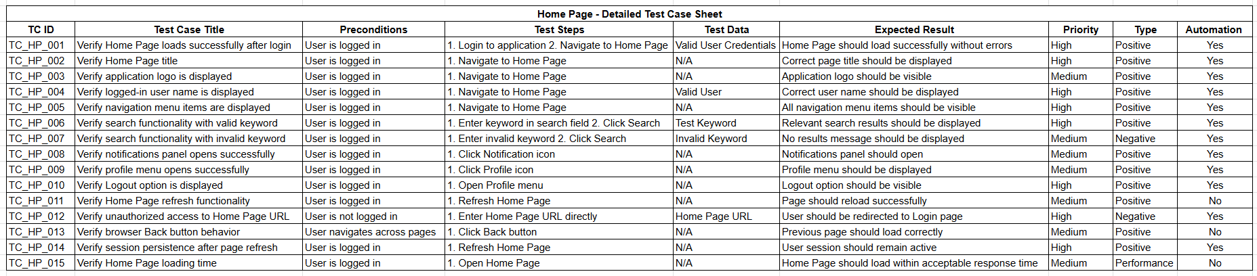
Login Module
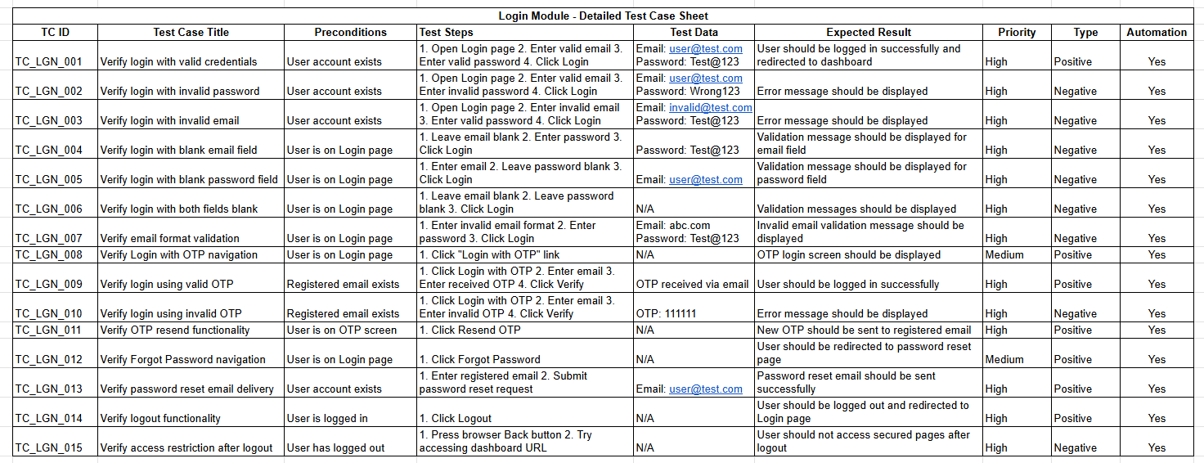

Logout Module
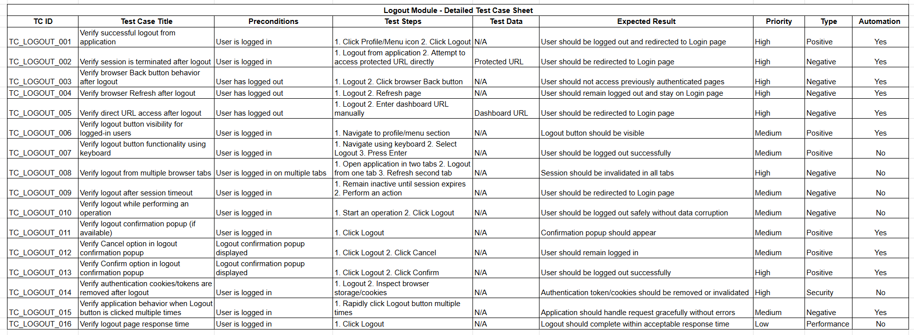

TASK 2
MANUAL TEST CASE
OTP Verification
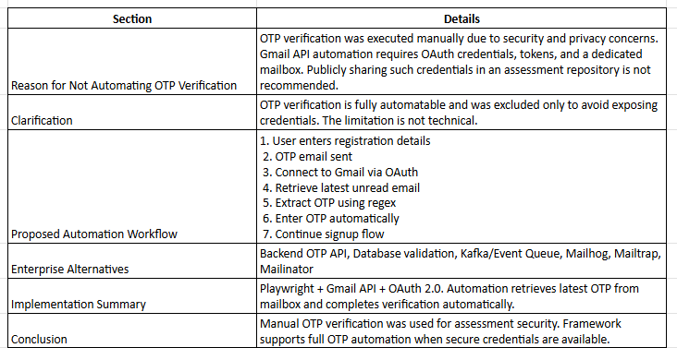
OTP Automation Approach
Reason for Not Automating OTP Verification in the Submitted Solution
During the assessment, the OTP verification step was executed manually instead of being fully automated.
The primary reason for this decision was security and privacy considerations. Automating OTP retrieval from Gmail requires granting programmatic access to an email account through Gmail API credentials and OAuth tokens. To implement this solution, a dedicated Gmail account would need to be created, verified with a mobile number, and configured with API access.
Since the assessment submission is intended to be publicly accessible through GitHub or another shared platform, including email credentials, OAuth configuration files, access tokens, or test account information would create security and privacy concerns. Therefore, I chose not to include Gmail-based OTP automation in the submitted framework.
Clarification
The OTP step is fully automatable and was not excluded due to a technical limitation.
A production-ready automation solution can retrieve the latest OTP directly from Gmail using the Gmail API, extract the OTP using regular expressions, and automatically complete the verification process without manual intervention.
The decision to keep OTP verification manual was made solely to avoid exposing personal or test account credentials and to keep the submission secure and self-contained.
Proposed Automation Approach
The OTP verification can be automated using the following workflow:
- User enters registration details.
- Application sends OTP to the registered email address.
- Automation connects to Gmail using OAuth authentication.
- Latest unread email is retrieved.
- OTP is extracted from the email body using a regular expression.
- OTP is entered into the verification field.
- Automation proceeds with the remaining Sign Up steps.
Real Enterprise Projects
In most companies, QA engineers rarely read OTPs from Gmail.
Instead they use:
- Backend OTP API
- Database
- Kafka/Event Queue
- Mailhog
- Mailtrap
- Mailinator
because they're more reliable.
Sample Implementation
The following method demonstrates how OTP verification can be automated after the OTP page is displayed:
import { Page } from '@playwright/test';
import { LatestOtp } from '../utils/LatestOtp';
export class NewUser {
constructor(private page: Page) {}
async fillUserDetails(
firstName: string,
lastName: string,
password: string
) {

await this.page
.getByPlaceholder(/first name/i)
.fill(firstName);

await this.page
.getByPlaceholder(/last name/i)
.fill(lastName);

await this.page
.getByPlaceholder(/^password$/i)
.fill(password);

await this.page
.getByPlaceholder(/re-type password/i)
.fill(password);

await this.page
.getByRole('button', {
name: /continue/i
})
.click();
}

async verifyOtp() {

await this.page.waitForTimeout(5000);

const otp =
await LatestOtp.getOtp();

await this.page
.locator('input[name="otp"]')
.fill(otp);

await this.page
.getByRole('button', {
name: /verify|continue/i
})
.click();
}
}

We can automate using Gmail API with OAuth 2.0 authentication. During initial setup, the test Gmail account grants permission and generates a token. The automation uses this token to access the mailbox securely, retrieve the latest OTP email, extract the OTP using regex, and complete the verification step automatically.
Conclusion
For the purpose of this assessment, OTP verification was tested manually to maintain security and avoid exposing email credentials or authentication tokens.
However, the framework design supports full OTP automation, and the implementation approach described above can be integrated whenever a dedicated test mailbox and secure API credentials are available.

Task 3
BUG
BUG-001
Title
OTP verification is restricted after approximately 15 verification attempts
Severity
Medium
Priority
Medium
Environment
- Browser: Chrome Latest
- OS: Windows 11
- Application: Almashines Sign Up Flow
Preconditions
User is on the OTP Verification page during the Sign Up process.
Steps to Reproduce
- Navigate to the Sign-Up page.
- Register using a valid email address.
- Proceed to the OTP verification step.
- Verify OTP multiple times using different test email accounts.
- Continue testing until approximately 15 OTP verification attempts are completed.
- Observe the system behaviour.

Expected Result
The platform should continue allowing OTP verification attempts for valid test users without imposing a hard limit during testing, or a clear message should be displayed explaining the restriction.
Actual Result
After approximately 15 OTP verification attempts, the system blocks further OTP verifications, preventing additional Sign-Up testing.
Impact
- Restricts QA testing activities.
- Prevents repeated execution of end-to-end automation tests.
- Causes test execution failures in regression and automation suites.
- Reduces productivity during validation of the Sign Up workflow.
Recommendation
- Remove the OTP verification limit in the testing/staging environment.
- Alternatively, provide configurable limits for test environments.
- Display a meaningful error message when the limit is reached.
- Consider whitelisting QA test accounts to avoid restrictions during automation execution.
Notes
This issue was observed while repeatedly testing the Sign Up flow and impacts both manual and automated testing efforts. The limitation may be intended for production security but should be relaxed or configurable in test environments.
BUG-002
Title
Leading and trailing spaces in Email field are not trimmed before validation
Severity
Medium
Priority
Medium
Environment
- Browser: Chrome Latest
- OS: Windows 11
Preconditions
User is on the Sign Up page.
Steps to Reproduce
- Enter an email address with leading or trailing spaces.
Example:
testuser@gmail.com
- Click Continue.
Expected Result
System should automatically trim spaces and validate the email correctly.
Actual Result
Email validation may fail or behave unexpectedly.
Impact
Users may be unable to proceed despite entering a valid email address.
Notes
This bug report is based on a common validation issue and should be marked as hypothetical if not reproducible during testing.

